Code Review: I2212180
Reviewer: Mark Dell
Date: June 6th, 2023

Bugs
- This is inaccessible code inside the outer If.
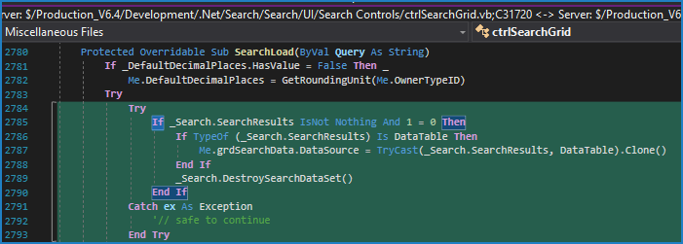

Preventative Action/Safety

Design/Architecture (Duplication, appropriate project, namespaces, maintainability)

Data Model (Naming, good design, needs index?)

Performance (Minimize DB hits, excessive loops, queries, scalable)

UI (Alignment, naming, standardization, tab order)

Error Handling (Behind events, appropriate parameter checking)

Cleanup (Dispose code, remove handlers, large data objects)

Readability (Well-named variables, methods, clear algorithm, is it understandable)
- Nit: It is recommended to use either our DataRowExtensionMethods or Microsoft’s DataSetExtensions, instead of long form coding, such as this, to get the value of a data cell in the correct data type. While our DataRowExtensionMethods are specific, Microsoft’s DataSetExtensions use generics to specify the data type and can convert DBNull to Nothing (according to Kevin). Note that I have not made much use of either as yet.
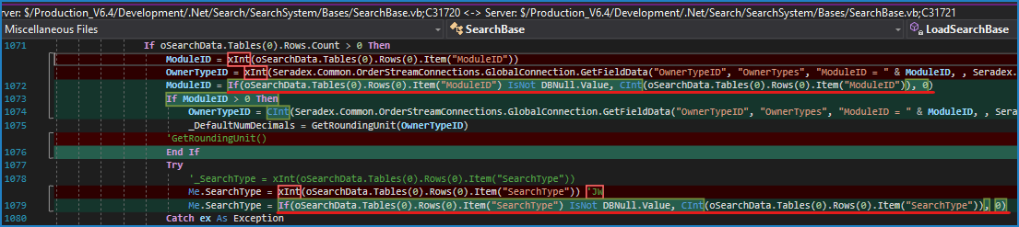

Comments (Useful, explains why rather than how)

Message Boxes (Grammar, spelling, captions, appropriate icons)

Ticket Management (Release Branch?, Testing Notes)

Extras
- Concern: Was there an issue with using the Disposed event of the form instead of moving the Dispose method from the designer code to the user code? (Same for ctrlSearchGrid). Please include a note to explain this. Note that some forms or controls clean up in the closed or closing event.
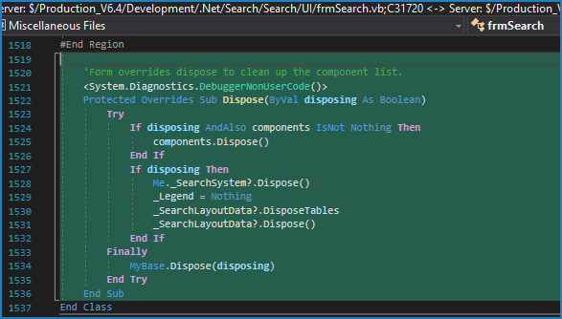
- Concern: Option Strict is Off in ctrlSearchGrid. Was that intentional? It appears that several other places in this file were updated so this could be On instead.

